Database Design Coursework Template

Student Name: Aman Messinezis

Student ID: adbt065

Student Number: 200004819

Scenario Topic Name E-commerce

Scenario (100 words maximum)

The database stores the details of the stock and staff in every warehouse for an e-commerce store. It also stores the customers and sellers that have accounts on the website, detailing the items they have bought. This database will not only keep a record of customers and sellers; it will also provide insightful information of all entities within the database, such as the types of stock people of a certain age buy. It keeps invoices of the stock items customers buy, too.

Example queries (Minimum 5 – list, who, which, how many, most, fewest etc. - check that your models have the attributes needed to answer the queries)

- Display all Customer IDs who have their birthdays today
- Display all Customer IDs that are also investors
- Display the card number of the user who owns Stock ID 3588 of ItemID 1266
- Display the category that people aged 50-60 are buying the most stock from
- Display the Warehouse ID that has the least number stock

Entity Relationship Model (insert a jpg image of your model exported from Visual Paradigm in the space below).

SCROLL DOWN

Conceptual Model

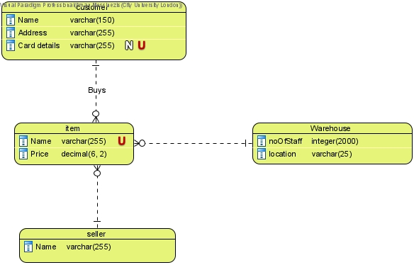

Logical Model
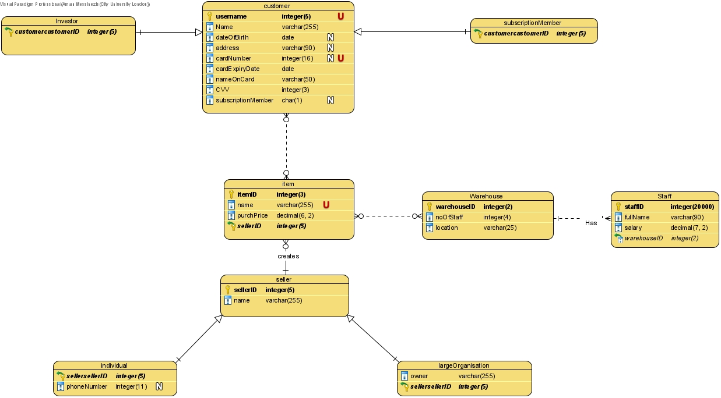

Physical Model
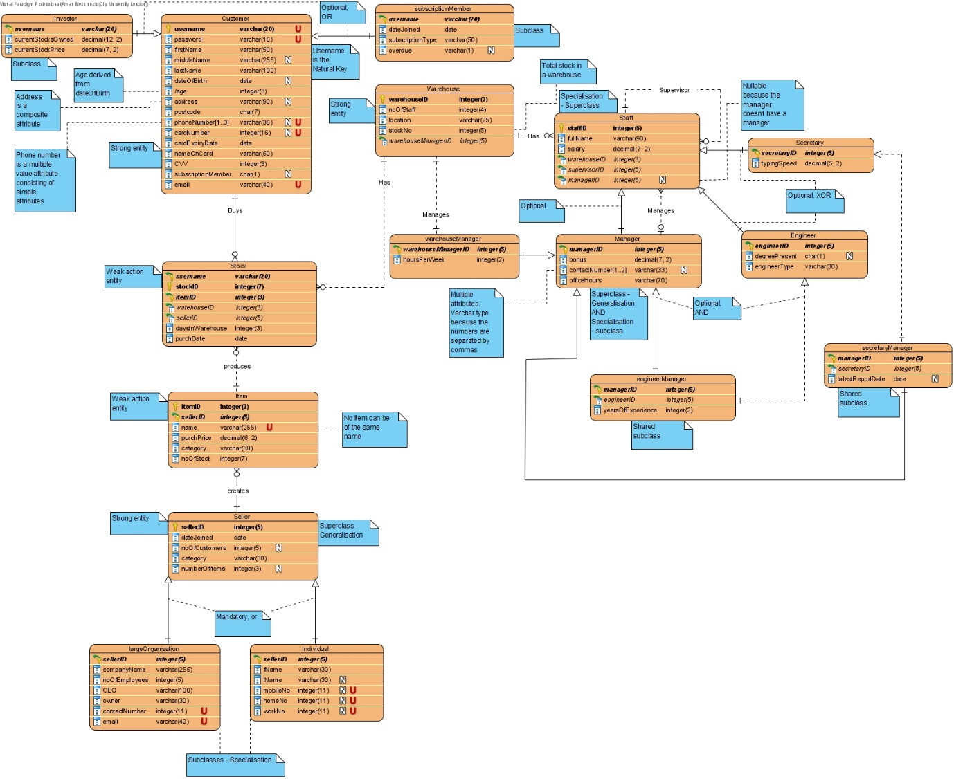

Relational Model Tables
- Copy and paste the table below for as many relational tables as you need
- Replace the placeholder names (table-name1, attribute-name5 etc) with the table and attribute names you derived from your ER model
- List primary key attributes first
- Add new rows to the tables (in the correct place) as needed
- Delete any unnecessary rows (attribute rows and foreign key rows if not used)
- Primary keys are to be specified in the format PRIMARY KEY (attribute-name1, attribute-name2, etc)
- Foreign keys are to be specified in the format ‘FOREIGN KEY (attribute-name) REFERENCES table-name (attribute-name)

“/” represents a derived attribute

Relational table specification | Marker’s corrections (Do not write in this column)
Table name: Customer
Attributes
firstName
middleName
lastName
dateOfBirth
/age
addressFirstLine
addressSecondLine
addressThirdLine
postcode
mobileNumber
homeNumber
workNumber
cardNumber
cardExpiryDate
nameOnCard
CVV
subscriptionMember
email
password
PRIMARY KEY (username)

Relational table specification | Marker’s corrections (Do not write in this column)
Table name: Investor
Attributes
above attributes
currentStocksOwned
currentStockPrice
PRIMARY KEY (username)
FOREIGN KEY (username) REFERENCES Customer (username)

Relational table specification | Marker’s corrections (Do not write in this column)
Table name: subscriptionMember
Attributes
Customer attributes
dateJoined
subscriptionType
overdue
PRIMARY KEY (username)
FOREIGN KEY (username) REFERENCES Customer (username)

Relational table specification | Marker’s corrections (Do not write in this column)
Table name: Seller
Attributes
dateJoined
noOfCustomers
category
numberOfItems
PRIMARY KEY (sellerID)

Relational table specification | Marker’s corrections (Do not write in this column)
Table name: largeOrganisation
Attributes
above attributes
companyName
noOfEmployees
CEO
owner
contactNumber
email
PRIMARY KEY (sellerID)
FOREIGN KEY (sellerID) REFERENCES Seller (sellerID)

Relational table specification | Marker’s corrections (Do not write in this column)
Table name: Individual
Attributes
Seller attributes
fName
lName
mobileNo
homeNo
workNo
PRIMARY KEY (sellerID)
FOREIGN KEY (sellerID) REFERENCES Seller (sellerID)

Relational table specification | Marker’s corrections (Do not write in this column)
Table name: Item
Attributes
name
purchPrice
category
noOfStock
PRIMARY KEY (itemID, sellerID)
FOREIGN KEY (sellerID) REFERENCES Seller (sellerID)

COMBINED ENTITY

Relational table specification | Marker’s corrections (Do not write in this column)
Table name: Warehouse and Warehouse Manager
Attributes
Manager attributes
noOfStaff
location
stockNo
hoursPerWeek
PRIMARY KEY (warehouseID)
FOREIGN KEY (warehouseManagerID) REFERENCES Manager (managerID)

Relational table specification | Marker’s corrections (Do not write in this column)
Table name: Staff
Attributes
fullName
salary
PRIMARY KEY (staffID)
FOREIGN KEY (warehouseID) REFERENCES Warehouse (warehouseID)
FOREIGN KEY (supervisorID) REFERENCES Staff (staffID)
FOREIGN KEY (managerID) REFERENCES Manager (managerID)

Relational table specification | Marker’s corrections (Do not write in this column)
Table name: Secretary
Attributes
above attributes
typingSpeed
PRIMARY KEY (secretaryID)
FOREIGN KEY (secretaryID) REFERENCES Staff (staffID)

Relational table specification | Marker’s corrections (Do not write in this column)
Table name: Engineer
Attributes
Staff attributes
degreePresent
engineerType
PRIMARY KEY (engineerID)
FOREIGN KEY (engineerID) REFERENCES Staff (staffID)

Relational table specification | Marker’s corrections (Do not write in this column)
Table name: Manager
Attributes
Staff attributes
bonus
workNumber
mobileNumber
PRIMARY KEY (managerID)
FOREIGN KEY (managerID) REFERENCES Staff (staffID)

Relational table specification | Marker’s corrections (Do not write in this column)
Table name: engineerManager
Attributes
Manager attributes AND Engineer attributes
yearsOfExperience
PRIMARY KEY (managerID)
FOREIGN KEY (managerID) REFERENCES Manager (managerID)
FOREIGN KEY (engineerID) REFERENCES Engineer (engineerID)

Relational table specification | Marker’s corrections (Do not write in this column)
Table name: secretaryManager
Attributes
Manager attributes AND Secretary attributes
latestReportDate
PRIMARY KEY (managerID)
FOREIGN KEY (managerID) REFERENCES Manager (managerID)
FOREIGN KEY (secretaryID) REFERENCES Engineer (secretaryID)

Relational table specification | Marker’s corrections (Do not write in this column)
Table name: Stock
Attributes
daysInWarehouse
purchDate
PRIMARY KEY (username, itemID)
FOREIGN KEY (username) REFERENCES Customer (username)
FOREIGN KEY (itemID) REFERENCES Item (itemID)
FOREIGN KEY (warehouseID) REFERENCES Warehouse (warehouseID)
FOREIGN KEY (sellerID) REFERENCES Seller (sellerID)

Marker’s Comments (Do not write in this section)

Important: Please note that marker’s corrections to your relational tables are there to help you construct a working database for the second coursework. They are not the determinant of your mark. For more information on how your work is assessed see the coursework specification and grade related criteria.

Coursework Mark (50 marks available):

